Create VM

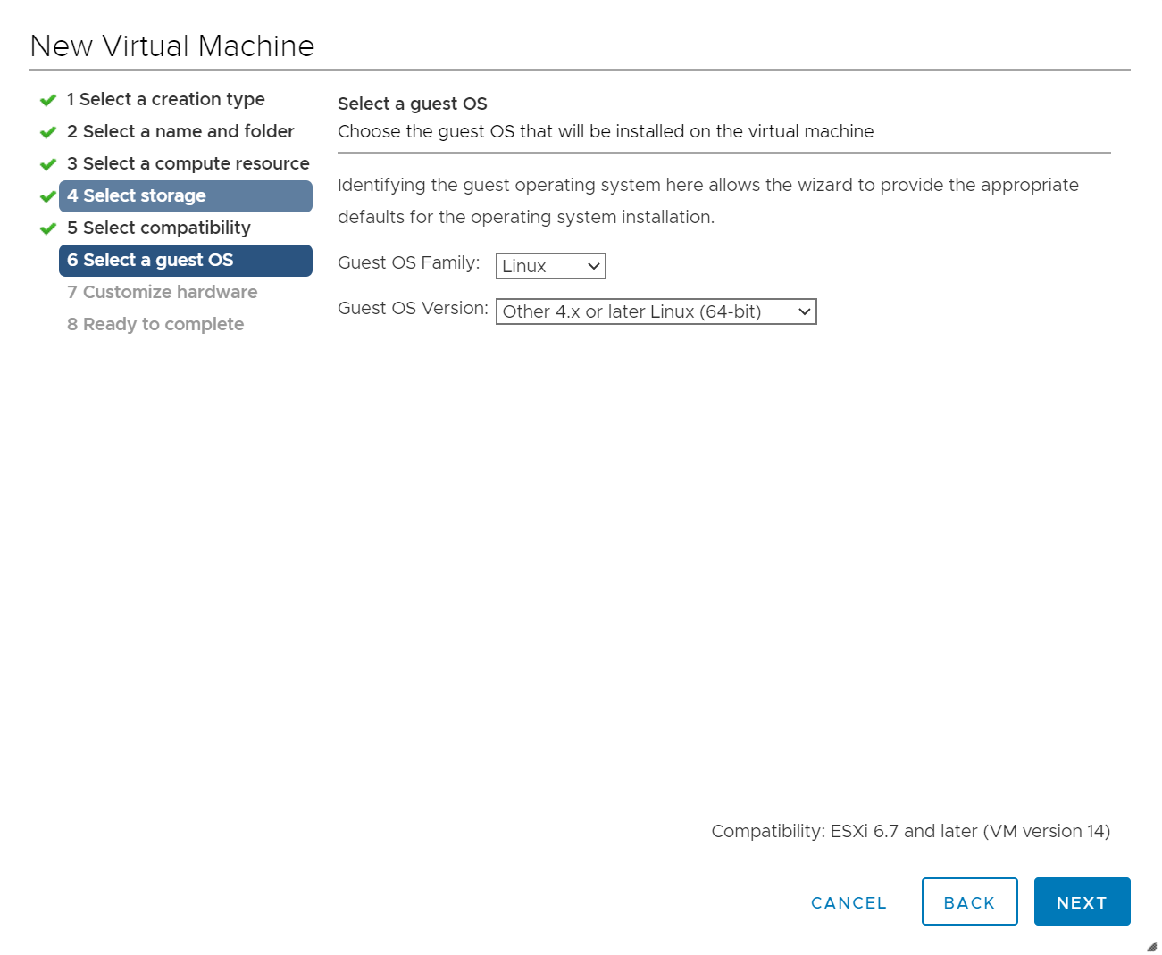

VM Hardware:

#Note: Hardisk need ~150GB

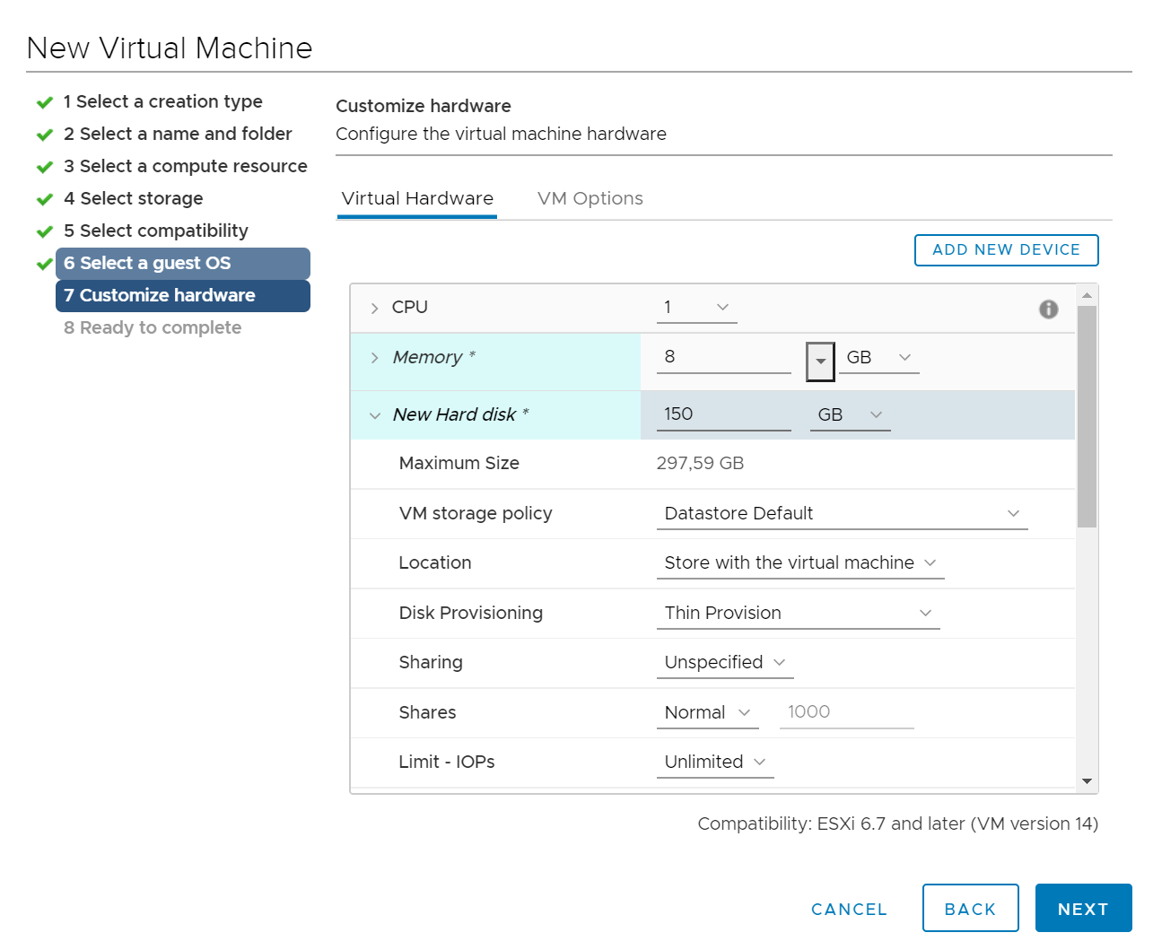

#VM option

Để Boot Option mode: BIOS

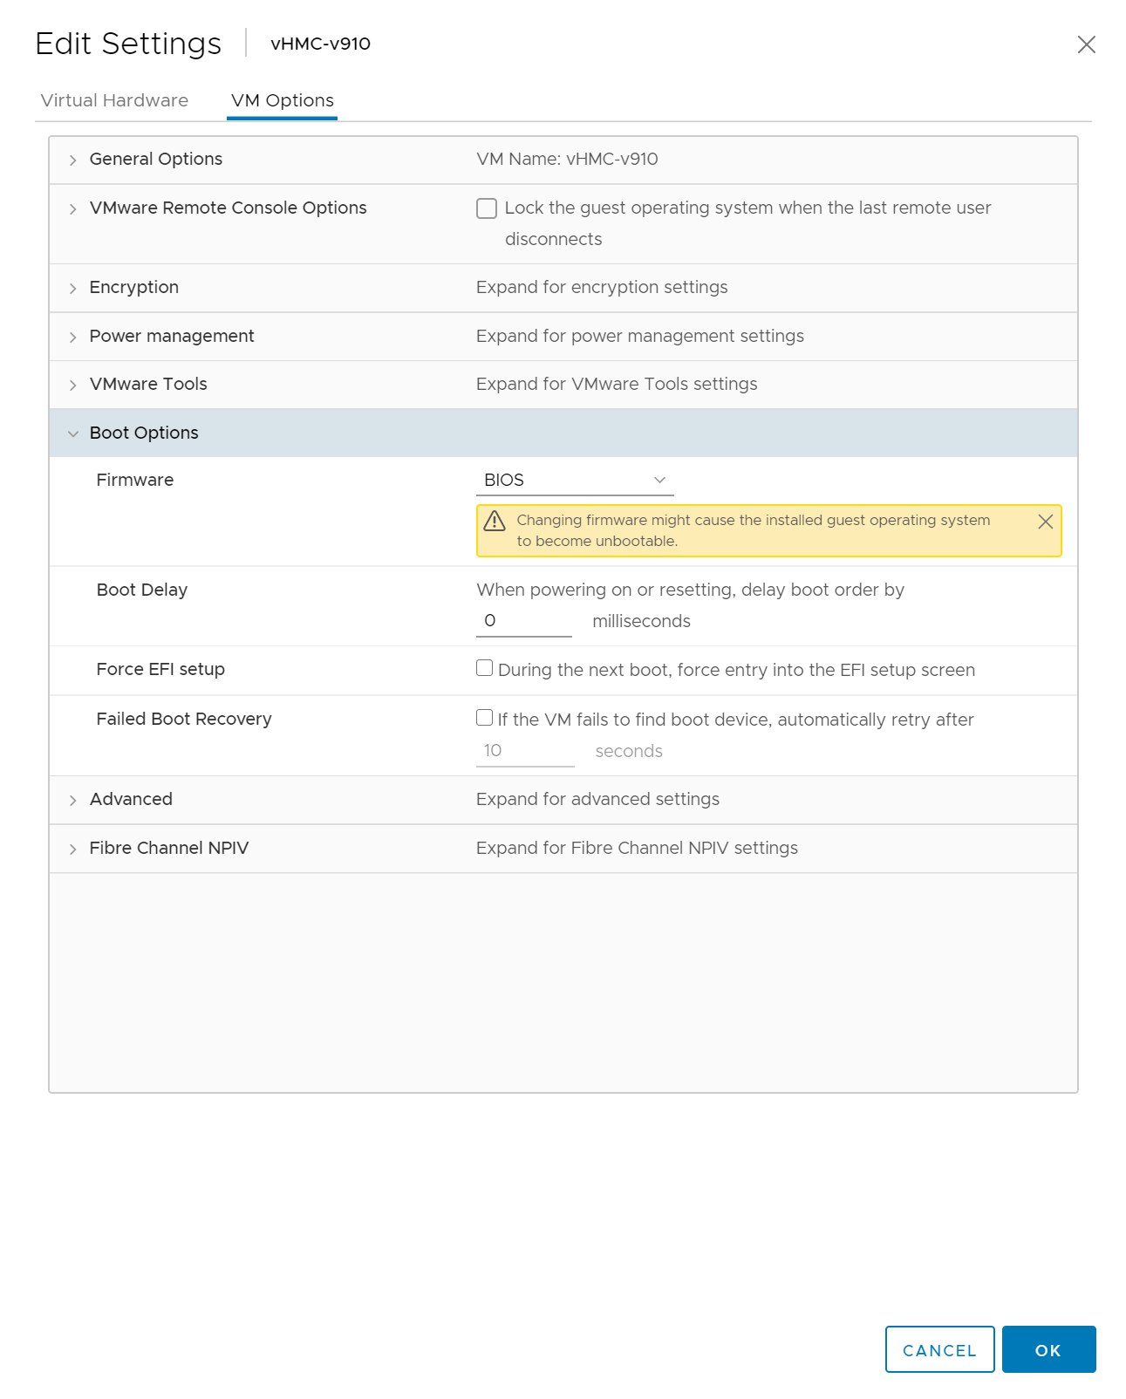

Nhét file : HMC_Recovery_V9R1M910_1_x86.iso vào ổ Cd/DVD và power on VM

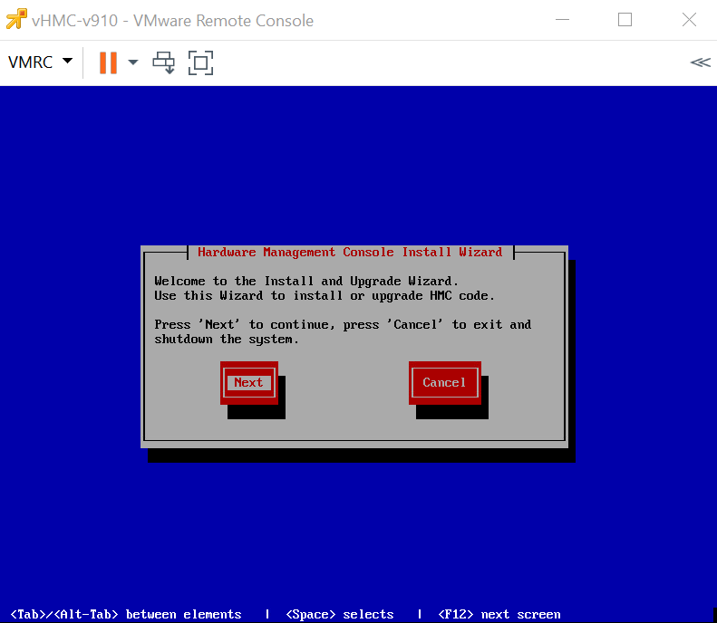

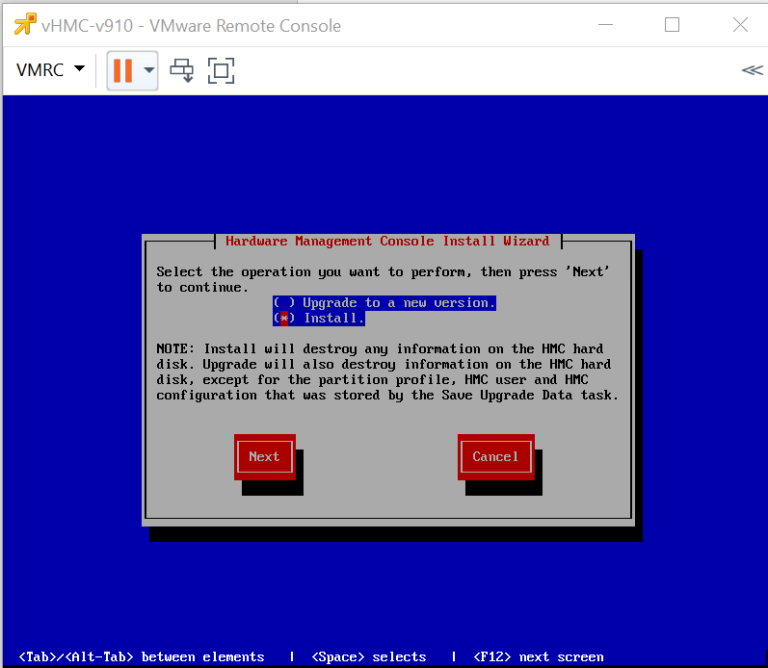

Sau do chon Finish de cai dat

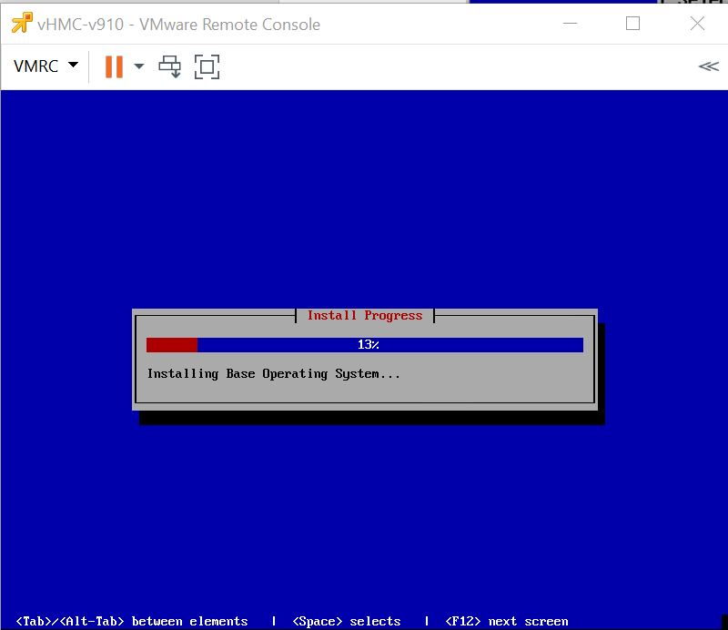

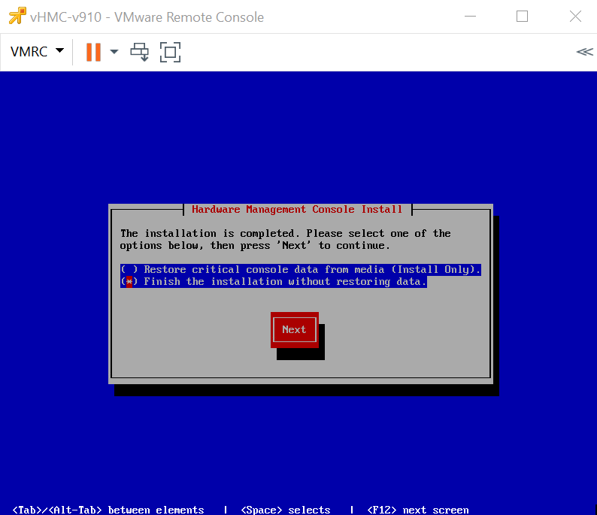

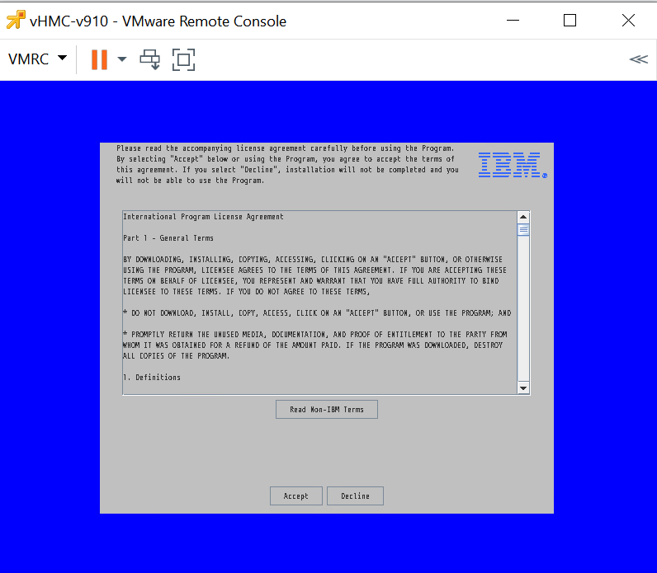

Accept License

Update to M940

**Nhét file iso vào ổ CD/DVD của VM vHMC**

* **HMC Management > Console Management**

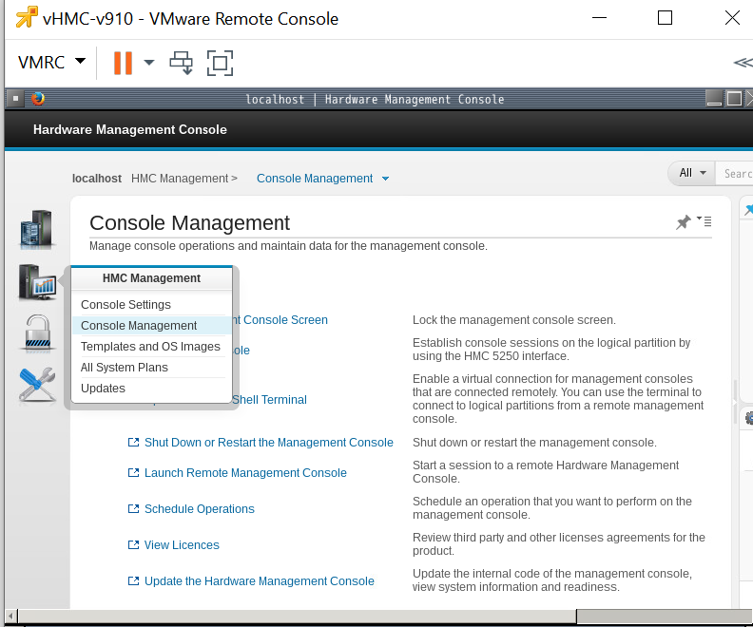

* click **Update the Hardware Management Console button**. The "HMC Install Corrective Service Wizard" panel is displayed.

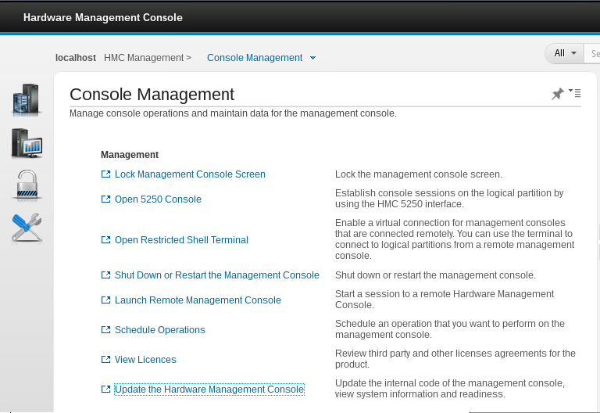

* HMC Driver Information panel, click Next.

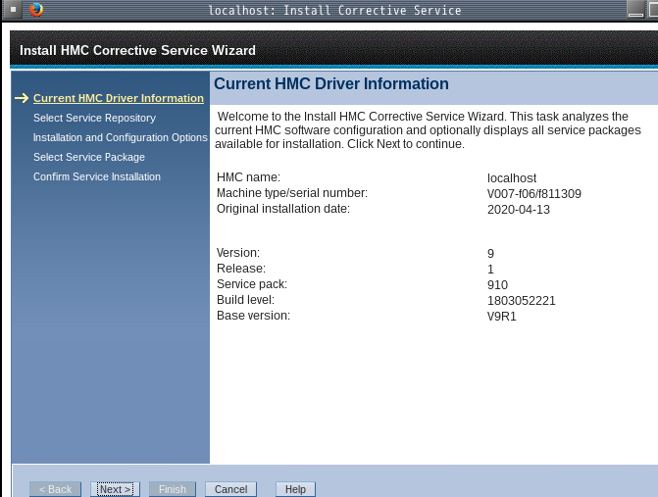

* On the Select Service Repository panel, click Removable Media, then click Next.

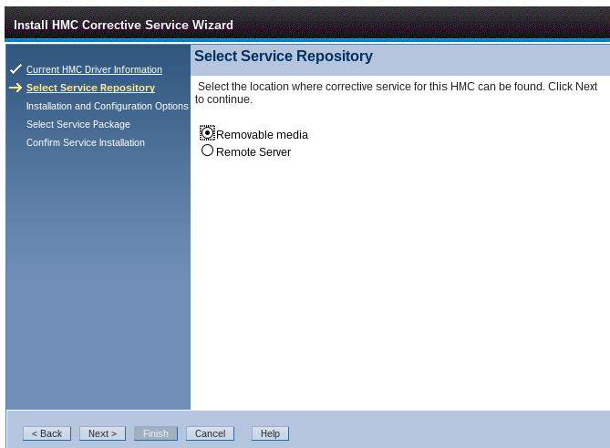

* On the Installation and Configuration Options panel, select either CD-ROM or DVD-RAM then click **Next**.

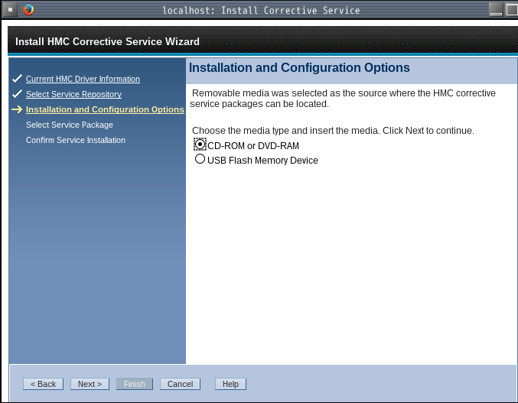

* On the Select Service Package panel, DVD image: select media image - no description, then click Next.

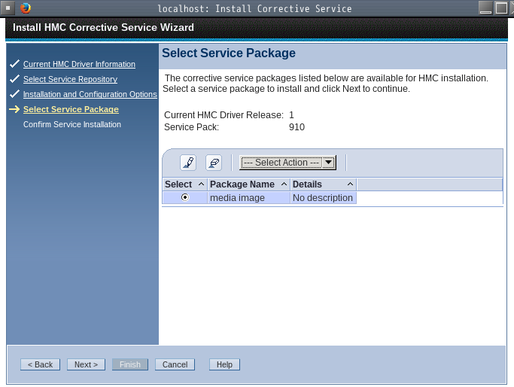

* On the Confirm Service Installation panel, click Finish .

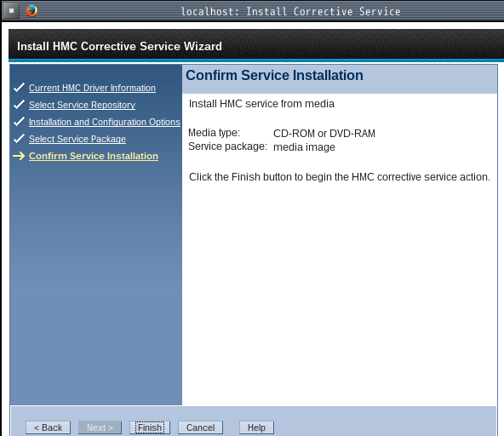

* HMC Install Corrective Service Progress panel indicates "Corrective Service installation was successful". Then, click OK.

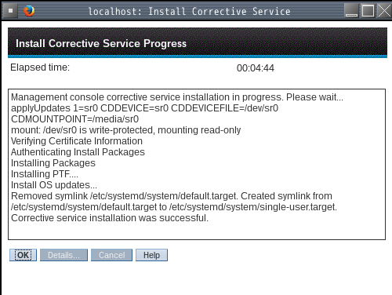

* Restart the HMC after the installation of the update has completed. The restart ensures all changes are available immediately. To reboot immediately, select **Yes**.

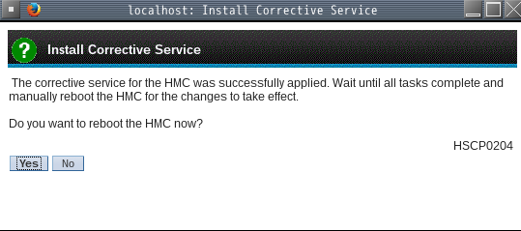

**#Note**: The HMC reboot may take several minutes longer than normal as some parts of the fix are applied during the reboot.

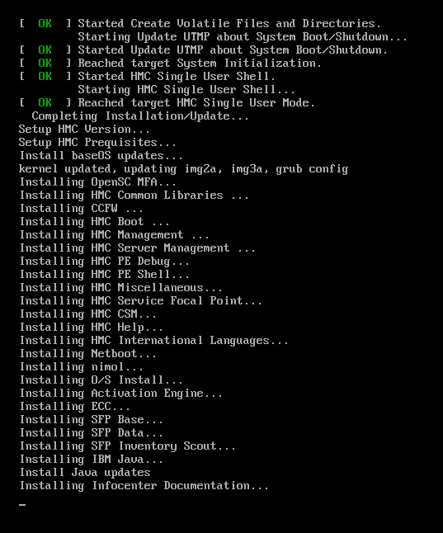

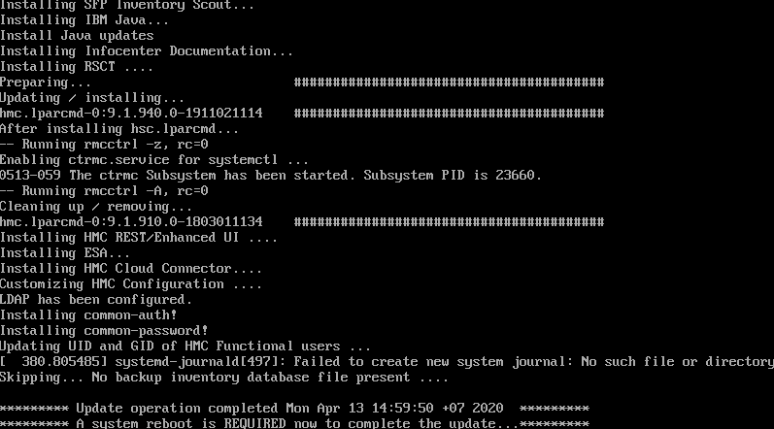

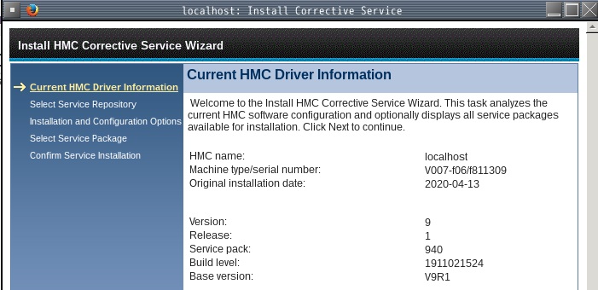

<https://www.ibm.com/support/pages/updates-hmc-v9r1>